IGNITE Registration Form
SEPTEMBER 2012 – MAY 2013

Please Print Clearly:

Child’s Last Name: _________________________ Child’s First Name:____________________

Mailing Address: _______________________________________________________________

City, State, Zip: ________________________________________________________________

Home Phone: __________________________________________________________________

E-mail Address: ________________________________________________________________

Date of Birth: ____________________________ School Grade: _________________________

School Attending: _______________________________________________________________

Please list known allergies: _______________________________________________________

EMERGENCY CONTACT INFORMATION:

Father’s Name: ________________________________________________________________

Father’s Cell Phone Number: _____________________________________________________

Mother’s Name: _______________________________________________________________

Mother’s Cell Phone Number: ____________________________________________________

PLEASE CONTACT THIS PERSON IF PARENTS/GUARDIANS CANNOT BE CONTACTED:

Name: __________________________________ Relation to child: _______________________

Home Phone: ________________________ Cell Phone: ____________________________

AUTHORIZATION FOR MEDICAL TREATMENT:

I _______________________________________ (parent’s name) hereby authorize IGNITE leaders to administer first aid and to obtain and consent to on my behalf any emergency first aid or medical care by any physician or hospital for my child, _______________________________ (child’s name). I agree to abide and be bound by such decisions and consents as if made by me. I further authorize any physician, hospital or medical attendant to receive full and complete medical reports or information deemed necessary with respect to the treatment of my child listed above. Execution of this document shall operate as an authorization for such person(s) to receive any medical information which they require.

Signature of Parent or Guardian: __________________________ Date: ________________

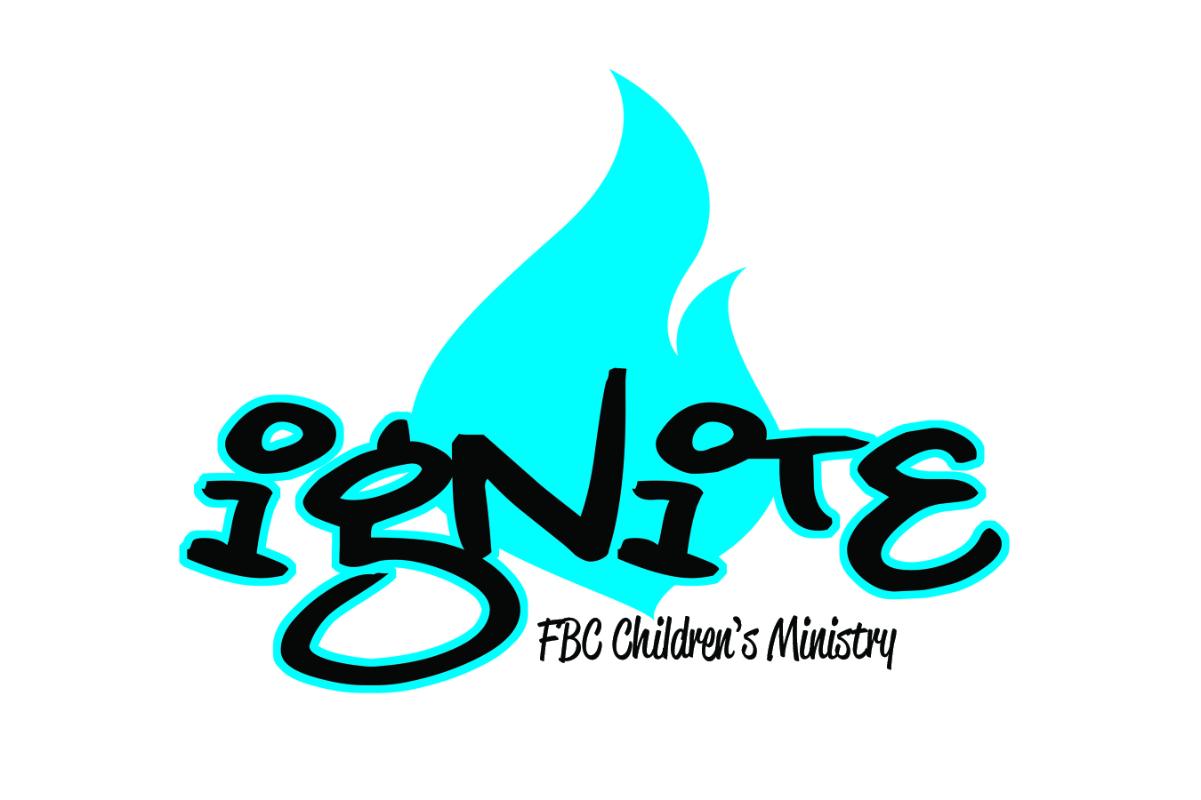

BEGINS September 5th!

Your child will not want to miss what is going on at FBC
on Wednesday nights!!
Our purpose is to: Ignite a passion for Christ and His word, which we do through fun activities and engaging lessons.

What is IGNITE?
Ignite is our Wednesday night discipleship and missions program from 6:30pm-8pm. Kids will begin and finish in AM-3. They will be divided into small groups by grade where their Discipleship group or Mission group leader will assist them in scripture memory, reviewing their daily Nehemiah Kids quiet time and leading activities and discussions about our mission focus.

What is Nehemiah Kids?
Nehemiah Kids is a discipleship program based out of Benbrook.
The Nehemiah Kids book is $7 per child or $18 per family max- please pay on or before Sept. 5
Each book contains an age appropriate daily quiet time and weekly memory verse. There is a parent talk page as well as a handbook that explains how to help your child complete the quiet times.

We hope to see you there!!!

